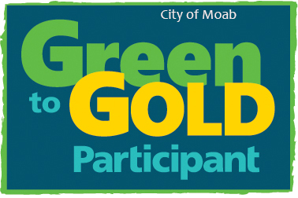 |  | St. Francis Episcopal Church  Easy Bee Farm  Youth Garden  City of Moab  Solid Waste District  Travel Council  UMTRA  KZMU  Multicultural Center  Atomic Lounge  98 Café  Moonflower Coop  Desert Bistro  Red Rock Bakery and Cafe  Spoke  Zax Wood Fired Pizza  Bike Fiend  Lost River Trading Co (Warehouse)  Moab Coffee Roosters  Ponderosa Energy  Ye ol Geezer  ACT Campground  Adventure Inn  Archway Inn  Creekside B & B  La Quinta  Moab Springs Ranch  Red Moon Lodge  Poison Spider Bicycles  Red River Adventures

CONTACT
PHONE:
304 584-3741

WEBSITE:
Sustainaablemoab.com

EMAIL:
rrusso@moabcity.org

